***KICKSTARTER CAMPAIGNS***

***Excel Analysis.***

1. **Given the provided data, what are three conclusions we can draw about Kickstarter campaigns?**

While analyzing Kickstarter campaigns, it is important to describe the category percentage over the general total. Consequently, the theater category has 1093 campaigns with a representation of 33.86%, the music category has 700 campaigns with a participation of 17.02%, the technology category has 600 campaigns with a percentage of 14.58%, the film & video category has 520 campaigns with 12.64%, the publishing category has 237 campaigns with 5.76%, the photography category has 220 campaigns with 5.35%, the games category has 220 campaigns with 5.35%, the food category has 200 campaigns with 4.86%, and the journalism category has 24 campaigns with 0.58% of the total category.

In the following analysis, each campaign and category will display the countries that had more impact. Moreover, their percentage of participation has been measured taking as reference the category total.

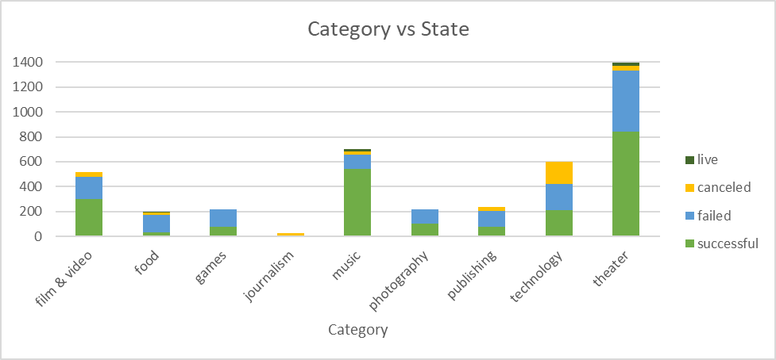

Figure 1

According to the comparison, category versus the current State (Figure 1), at first glance, the successful campaigns have three categories, out of nine analyzed, that have a success rate of over 50% of the total. Those are music (77.14%), theater (60.23%), and film and video (57.69%).

In a further analysis of the categories mentioned, those with the best impact are the theater campaign which has a reception in countries such as the United States (37.69%), Great Britain (18.52%), and Canada (2.01%). “Plays”, a sub-category in theater, has a substantial number of successes and no campaigns canceled (Figure 2).

Music has captivity distributed in countries such as the United States (70.00%), Great Britain (3.57%), and Canada (1.43%). In addition, the sub-categories “rock” and “indie rock” are the most representative, being the first one with more success and no cancelation.

Film & video has impacted countries like the United States (50.19%), Great Britain (3.57%), and Canada (1.15%). The sub-category with the most engagement is “documentary”, followed by “shorts” and “television” (Figure 2).

In the same graphic (Figure 1), it can be observed that the live campaigns have not developed such captivity as the successful ones. However, it must be mentioned that it has 50 campaigns and represents 1.22% of the total of shows distributed mostly in theater and music categories.

The theater category has the sub-categories “plays” and “spaces” that are considered the most representative, and the music category had all his production concentrated in the sub-category “faith”.

An approach to the canceled campaigns, the category represents 8.48% of the general total with shows on technology in the United States (20.17%), Great Britain (2.00%), and Canada (1.67%). The sub-category with the most impact is “web”; on film & video shows in the United States (5.96%), Canada (0.58%), and Australia (0.38%). The sub-category that was affected is “science fiction” (Figure 2); on theater shows in the United States (1.87%), Great Britain (0.43%), and Australia (0.14%). The sub-category with less captivity is “musical”.

The category with the most impact is journalism with a total cancelation assuming the reason is that it had been produced only on the audio sub-category in all countries. (Figure 2).

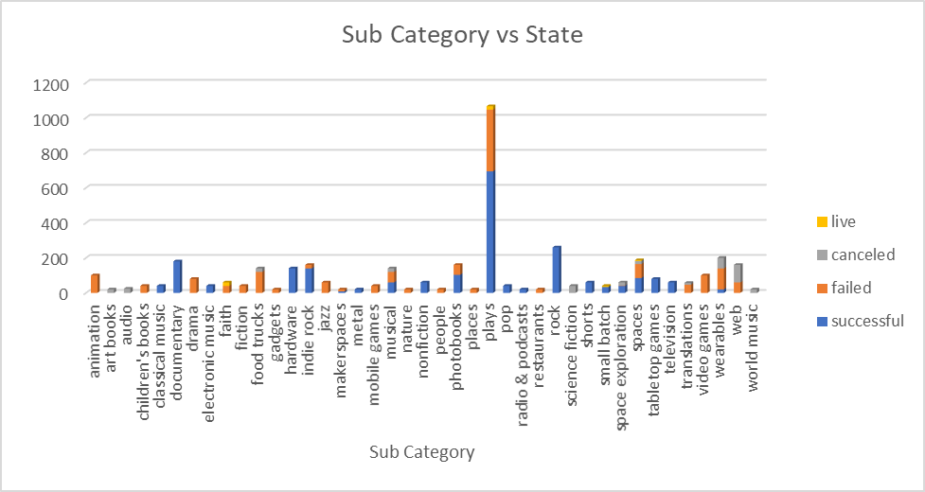

Figure 2

The failed campaigns show that the impact has been directed to the categories as theater (35.39%), technology (35.50%), and film & video (34.62%) of the total. The first one has a big distribution among the United States (25.05%), Great Britain (6.39%), and Canada (1.08%). The sub-categories affected are “plays”, “spaces”, and “musical” (Figure 2).

The second one had an impact in The United States (23.00%), Great Britain (3.17%), and Canada (2.33%), and the subcategories affected were “wearables”, “web”, “gadgets”, “maker spaces”, and “space exploration”.

Film & video is the last one in this category, it has distribution within the United States (25.00%), Great Britain (5.17%), and Canada (1.35%). The subcategories that were impacted are “animation” and “drama” (Figure 2).

Reviewing the evolution of State, the data shown is based on information from 2009 to 2017 and includes the categories, subcategories, and the state. It is important to remark that the live category only had been active for a few months in the year 2017. This is the reason why it had not been shown in the graphic (Figure 3).

As we can see, the highest point is in May with 234 successful campaigns and 5.69% of the total. The data shows that in May 2014 were 58 campaigns, in 2015, there were 68, and in 2016 there were 58 campaigns. Those 3 years agreed that the sub-category with more demand is “plays”.

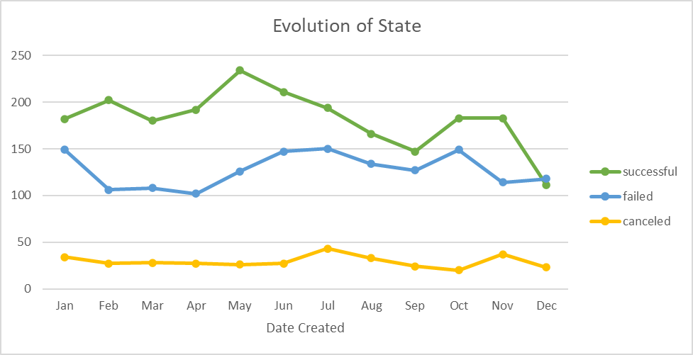

Figure 3

Additionally, the lowest point for successful campaigns is in December with the participation of 2.70%  or 111 campaigns, and the least popular sub-categories were “electronic music” and “pop” in the music category.

The failed campaigns have their lowest point in April with 2.51% or 192 campaigns. The category that had more failure was the theater with the sub-category “plays”. However, the higher point was in July with 3.69% or 150 campaigns, and the theater category had 50 failure campaigns with the sub-categories “plays”, “spaces”, and “musical”.

The canceled campaigns had their higher point in November with 0.91% or 37 campaigns. In 2014, 16 campaigns were canceled, and the sub-categories were “web”, “wearables”, “science fiction”, “space exploration”, “art books”, and “musical”. The lowest point was in October with 0.49% or 20 campaigns. In 2014, 10 campaigns were canceled and the subcategories were “science fiction”, “wearables”, “translations”, “world music”, “web”, “audio”, and “space exploration”.

In conclusion:

* Live campaigns only have information from 2017 which can not be compared properly in the Date Created graph.
* The sub-category “plays” is the most successful, at the same time, it had the most failure or canceled.
* The years 2014, 2015, and 2016 have the most substantial data, compiling 76.59% of the total.
* The failed and canceled campaigns are lower (45.67%) than successful campaigns (53.11%).
* All successful campaigns were funded over 100%.

1. **What are some limitations of this dataset?**

This data does not have detailed information on the revenues of each subcategory or category. Also, it does not provide information about the audiences such as target rating points which could be helpful to analyze the success, failure, or cancelation of any campaign.

1. **What are some other possible tables and/or graphs that we could create?**

* Yearly/monthly analysis by sub-category and actual state. For a better understanding of peak seasons.
* The combination of countries with actual states, categories, and subcategories would define the preference of the audience.
* A relationship between campaign goal and amount pledged. For fulfilling goals.
* Time length of a subcategory and actual rate. The connection between those variables would give us the life cycle of the campaign.